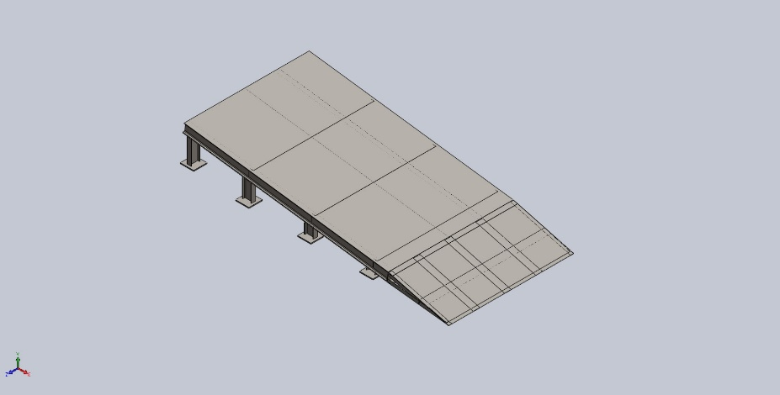
  Simulation of 0403Assem1
  Date: 15 APRIL 2025
  Designer: BHARATI SABALE
  Study name: Static 2
  Analysis type: Static
  Table of Contents
  Description 1
  Assumptions 2
  Model Information 3
  Study Properties 12
  Units 13
  Material Properties 14
  Loads and Fixtures 17
  Connector Definitions 18
  Interaction Information 18
  Mesh information 19
  Sensor Details 19
  Resultant Forces 20
  Beams 21
  Study Results 29
  Conclusion 31

Description
No Data

Assumptions

Model Information

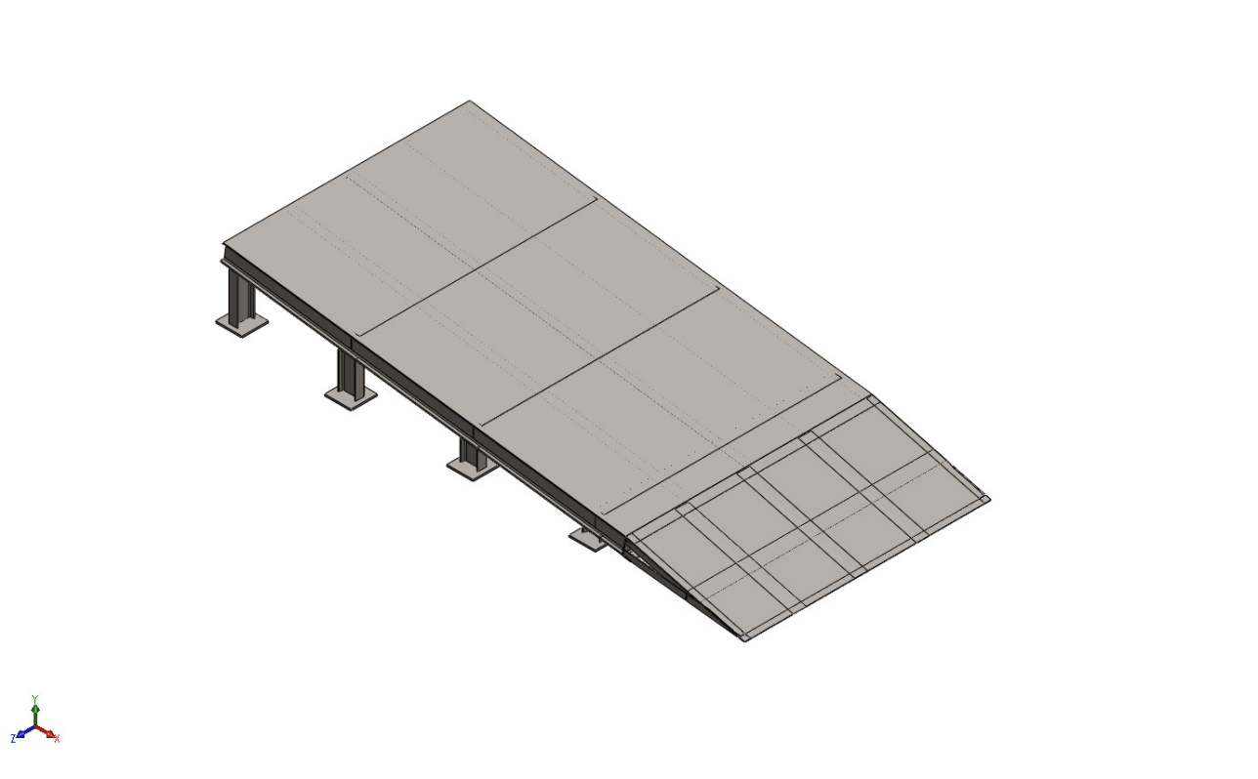
Model name: 0403Assem1
Current Configuration: Default
Solid Bodies
Document Name and Reference | Treated As | Volumetric Properties | Document Path/Date Modified
Boss-Extrude1  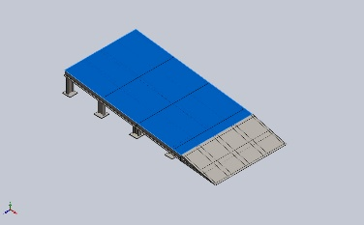 | Solid Body | Mass:126.66 kg  Volume:0.016135 m^3  Density:7,850 kg/m^3  Weight:1,241.27 N | E:\NIHVA AUTOMATION 2026\AUTOMATION\DOCK RAMP\DOCK RAMP- ASSA ABLOY 04\0403CHEQURED PLATE.SLDPRT  Oct 19 18:40:39 2025
Boss-Extrude1  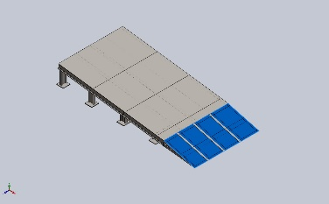 | Solid Body | Mass:38.465 kg  Volume:0.0049 m^3  Density:7,850 kg/m^3  Weight:376.957 N | E:\NIHVA AUTOMATION 2026\AUTOMATION\DOCK RAMP\DOCK RAMP- ASSA ABLOY 04\0403SS PLATE.SLDPRT  Oct 21 06:22:15 2025
Boss-Extrude1  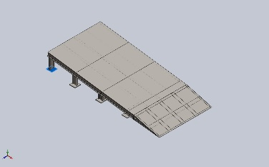 | Solid Body | Mass:1.76625 kg  Volume:0.000225 m^3  Density:7,850 kg/m^3  Weight:17.3092 N | E:\NIHVA AUTOMATION 2026\AUTOMATION\DOCK RAMP\DOCK RAMP- ASSA ABLOY 04\0403bottom plate.SLDPRT  Oct 19 18:40:39 2025
Boss-Extrude1  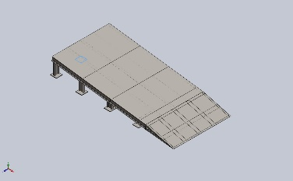 | Solid Body | Mass:1.76625 kg  Volume:0.000225 m^3  Density:7,850 kg/m^3  Weight:17.3092 N | E:\NIHVA AUTOMATION 2026\AUTOMATION\DOCK RAMP\DOCK RAMP- ASSA ABLOY 04\0403bottom plate.SLDPRT  Oct 19 18:40:39 2025
Boss-Extrude1  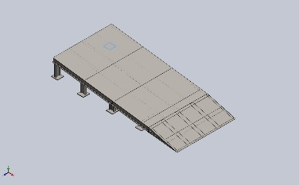 | Solid Body | Mass:1.76625 kg  Volume:0.000225 m^3  Density:7,850 kg/m^3  Weight:17.3092 N | E:\NIHVA AUTOMATION 2026\AUTOMATION\DOCK RAMP\DOCK RAMP- ASSA ABLOY 04\0403bottom plate.SLDPRT  Oct 19 18:40:39 2025
Boss-Extrude1  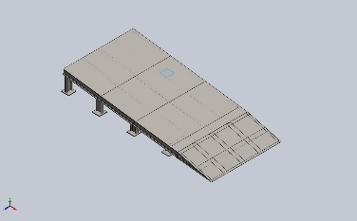 | Solid Body | Mass:1.76625 kg  Volume:0.000225 m^3  Density:7,850 kg/m^3  Weight:17.3093 N | E:\NIHVA AUTOMATION 2026\AUTOMATION\DOCK RAMP\DOCK RAMP- ASSA ABLOY 04\0403bottom plate.SLDPRT  Oct 19 18:40:39 2025
Boss-Extrude1  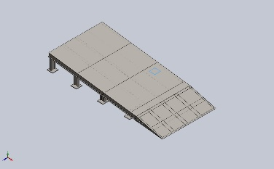 | Solid Body | Mass:1.76625 kg  Volume:0.000225 m^3  Density:7,850 kg/m^3  Weight:17.3092 N | E:\NIHVA AUTOMATION 2026\AUTOMATION\DOCK RAMP\DOCK RAMP- ASSA ABLOY 04\0403bottom plate.SLDPRT  Oct 19 18:40:39 2025
Boss-Extrude1  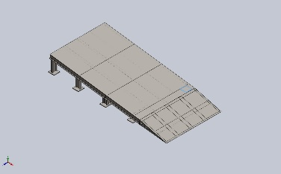 | Solid Body | Mass:1.76625 kg  Volume:0.000225 m^3  Density:7,850 kg/m^3  Weight:17.3092 N | E:\NIHVA AUTOMATION 2026\AUTOMATION\DOCK RAMP\DOCK RAMP- ASSA ABLOY 04\0403bottom plate.SLDPRT  Oct 19 18:40:39 2025
Boss-Extrude1  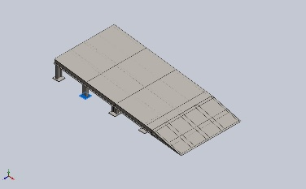 | Solid Body | Mass:1.76625 kg  Volume:0.000225 m^3  Density:7,850 kg/m^3  Weight:17.3092 N | E:\NIHVA AUTOMATION 2026\AUTOMATION\DOCK RAMP\DOCK RAMP- ASSA ABLOY 04\0403bottom plate.SLDPRT  Oct 19 18:40:39 2025
Boss-Extrude1  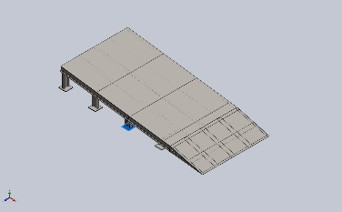 | Solid Body | Mass:1.76625 kg  Volume:0.000225 m^3  Density:7,850 kg/m^3  Weight:17.3092 N | E:\NIHVA AUTOMATION 2026\AUTOMATION\DOCK RAMP\DOCK RAMP- ASSA ABLOY 04\0403bottom plate.SLDPRT  Oct 19 18:40:39 2025
Boss-Extrude1  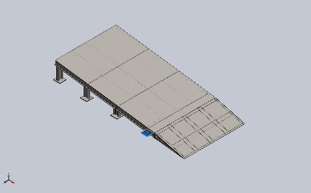 | Solid Body | Mass:1.76625 kg  Volume:0.000225 m^3  Density:7,850 kg/m^3  Weight:17.3092 N | E:\NIHVA AUTOMATION 2026\AUTOMATION\DOCK RAMP\DOCK RAMP- ASSA ABLOY 04\0403bottom plate.SLDPRT  Oct 19 18:40:39 2025
Beam Bodies:
Document Name and Reference | Formulation | Properties | Document Path/Date Modified
SolidBody 1(Trim/Extend1[3])  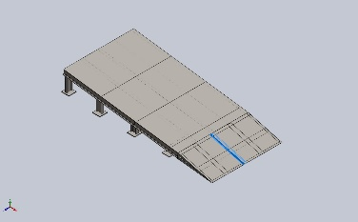 | Beam – Uniform C/S | Section Standard-  Section Area: 0.000856274m^2  Length:693.682mm  Volume:0.000479396m^3  Mass Density:7,850kg/m^3  Mass:3.76326kg  Weight:36.88N | E:\NIHVA AUTOMATION 2026\AUTOMATION\DOCK RAMP\DOCK RAMP- ASSA ABLOY 04\0403DOCK RAMP2.SLDPRT  Oct 21 06:22:14 2025
SolidBody 2(C channel 100 X 10(1))  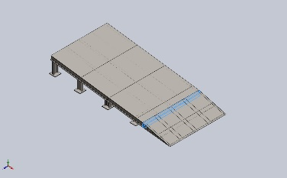 | Beam – Uniform C/S | Section Standard-weldment profiles/iso/c channel  Section Area: 0.00131018m^2  Length:1,400mm  Volume:0.00183425m^3  Mass Density:7,850kg/m^3  Mass:14.3988kg  Weight:141.109N | E:\NIHVA AUTOMATION 2026\AUTOMATION\DOCK RAMP\DOCK RAMP- ASSA ABLOY 04\0403DOCK RAMP2.SLDPRT  Oct 21 06:22:14 2025
SolidBody 3(Angle iron 35 X 35 X 5(1)[1])  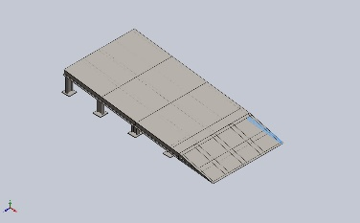 | Beam – Uniform C/S | Section Standard-weldment profiles/iso/angle iron  Section Area: 0.000319635m^2  Length:676.965mm  Volume:0.000201915m^3  Mass Density:7,850kg/m^3  Mass:1.58504kg  Weight:15.5333N | E:\NIHVA AUTOMATION 2026\AUTOMATION\DOCK RAMP\DOCK RAMP- ASSA ABLOY 04\0403DOCK RAMP2.SLDPRT  Oct 21 06:22:14 2025
SolidBody 4(Angle iron 35 X 35 X 5(1)[2])  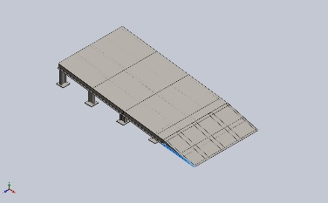 | Beam – Uniform C/S | Section Standard-weldment profiles/iso/angle iron  Section Area: 0.000319635m^2  Length:668.363mm  Volume:0.00020192m^3  Mass Density:7,850kg/m^3  Mass:1.58507kg  Weight:15.5337N | E:\NIHVA AUTOMATION 2026\AUTOMATION\DOCK RAMP\DOCK RAMP- ASSA ABLOY 04\0403DOCK RAMP2.SLDPRT  Oct 21 06:22:14 2025
SolidBody 5(Trim/Extend1[5])  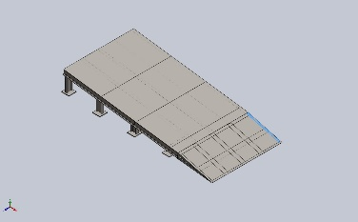 | Beam – Uniform C/S | Section Standard-  Section Area: 0.000319635m^2  Length:650.834mm  Volume:0.000155116m^3  Mass Density:7,850kg/m^3  Mass:1.21766kg  Weight:11.9331N | E:\NIHVA AUTOMATION 2026\AUTOMATION\DOCK RAMP\DOCK RAMP- ASSA ABLOY 04\0403DOCK RAMP2.SLDPRT  Oct 21 06:22:14 2025
SolidBody 6(Cut-Extrude2)  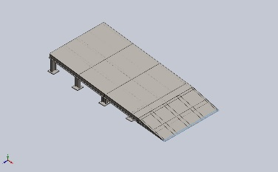 | Beam – Uniform C/S | Section Standard-weldment profiles/iso/angle iron  Section Area: 8.65191e-05m^2  Length:1,400mm  Volume:0.000121127m^3  Mass Density:7,850kg/m^3  Mass:0.950845kg  Weight:9.31828N | E:\NIHVA AUTOMATION 2026\AUTOMATION\DOCK RAMP\DOCK RAMP- ASSA ABLOY 04\0403DOCK RAMP2.SLDPRT  Oct 21 06:22:14 2025
SolidBody 7(Cut-Extrude4)  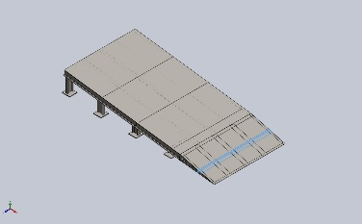 | Beam – Uniform C/S | Section Standard-weldment profiles/iso/angle iron  Section Area: 0.000715454m^2  Length:1,400mm  Volume:0.00100164m^3  Mass Density:7,850kg/m^3  Mass:7.86284kg  Weight:77.0558N | E:\NIHVA AUTOMATION 2026\AUTOMATION\DOCK RAMP\DOCK RAMP- ASSA ABLOY 04\0403DOCK RAMP2.SLDPRT  Oct 21 06:22:14 2025
SolidBody 8(Trim/Extend1[1])  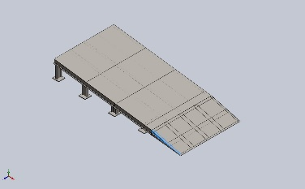 | Beam – Uniform C/S | Section Standard-  Section Area: 0.000319635m^2  Length:650.834mm  Volume:0.000155116m^3  Mass Density:7,850kg/m^3  Mass:1.21766kg  Weight:11.9331N | E:\NIHVA AUTOMATION 2026\AUTOMATION\DOCK RAMP\DOCK RAMP- ASSA ABLOY 04\0403DOCK RAMP2.SLDPRT  Oct 21 06:22:14 2025
SolidBody 9(Trim/Extend1[2])  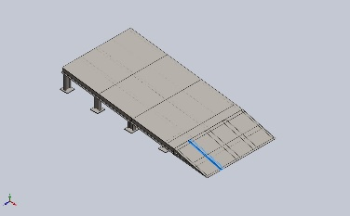 | Beam – Uniform C/S | Section Standard-  Section Area: 0.000856274m^2  Length:693.682mm  Volume:0.000479396m^3  Mass Density:7,850kg/m^3  Mass:3.76326kg  Weight:36.88N | E:\NIHVA AUTOMATION 2026\AUTOMATION\DOCK RAMP\DOCK RAMP- ASSA ABLOY 04\0403DOCK RAMP2.SLDPRT  Oct 21 06:22:14 2025
SolidBody 10(Trim/Extend1[4])  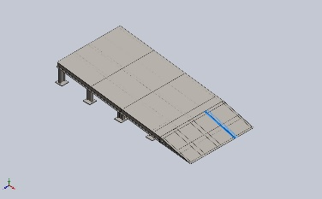 | Beam – Uniform C/S | Section Standard-  Section Area: 0.000856274m^2  Length:693.682mm  Volume:0.000479396m^3  Mass Density:7,850kg/m^3  Mass:3.76326kg  Weight:36.88N | E:\NIHVA AUTOMATION 2026\AUTOMATION\DOCK RAMP\DOCK RAMP- ASSA ABLOY 04\0403DOCK RAMP2.SLDPRT  Oct 21 06:22:14 2025
SolidBody 1(Cut-Extrude2[5])  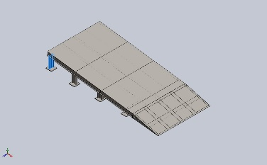 | Beam – Uniform C/S | Section Standard-weldment profiles/iso/sb beam  Section Area: 0.00109003m^2  Length:300mm  Volume:0.000327009m^3  Mass Density:7,850kg/m^3  Mass:2.56702kg  Weight:25.1568N | E:\NIHVA AUTOMATION 2026\AUTOMATION\DOCK RAMP\DOCK RAMP- ASSA ABLOY 04\0403sissior lift ramp.SLDPRT  Oct 21 14:04:33 2025
SolidBody 2(Cut-Extrude2[13])  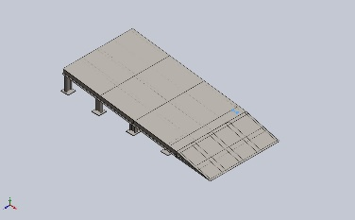 | Beam – Uniform C/S | Section Standard-weldment profiles/iso/sb beam  Section Area: 0.000107189m^2  Length:92.0026mm  Volume:2.59644e-05m^3  Mass Density:7,850kg/m^3  Mass:0.20382kg  Weight:1.99744N | E:\NIHVA AUTOMATION 2026\AUTOMATION\DOCK RAMP\DOCK RAMP- ASSA ABLOY 04\0403sissior lift ramp.SLDPRT  Oct 21 14:04:33 2025
SolidBody 3(C channel 100 X 10(1)[3])  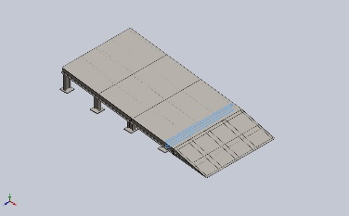 | Beam – Uniform C/S | Section Standard-weldment profiles/iso/c channel  Section Area: 0.00131018m^2  Length:1,350mm  Volume:0.00176874m^3  Mass Density:7,850kg/m^3  Mass:13.8846kg  Weight:136.069N | E:\NIHVA AUTOMATION 2026\AUTOMATION\DOCK RAMP\DOCK RAMP- ASSA ABLOY 04\0403sissior lift ramp.SLDPRT  Oct 21 14:04:33 2025
SolidBody 4(Cut-Extrude2[10])  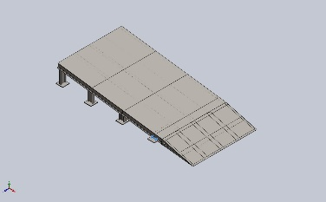 | Beam – Uniform C/S | Section Standard-weldment profiles/iso/sb beam  Section Area: 0.000107189m^2  Length:92.0026mm  Volume:2.59644e-05m^3  Mass Density:7,850kg/m^3  Mass:0.20382kg  Weight:1.99744N | E:\NIHVA AUTOMATION 2026\AUTOMATION\DOCK RAMP\DOCK RAMP- ASSA ABLOY 04\0403sissior lift ramp.SLDPRT  Oct 21 14:04:33 2025
SolidBody 5(Cut-Extrude5[6])  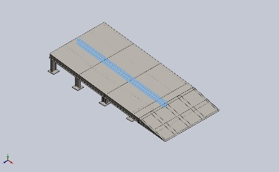 | Beam – Uniform C/S | Section Standard-weldment profiles/iso/sb beam  Section Area: 0.00109003m^2  Length:2,265.04mm  Volume:0.0024703m^3  Mass Density:7,850kg/m^3  Mass:19.3919kg  Weight:190.04N | E:\NIHVA AUTOMATION 2026\AUTOMATION\DOCK RAMP\DOCK RAMP- ASSA ABLOY 04\0403sissior lift ramp.SLDPRT  Oct 21 14:04:33 2025
SolidBody 6(Cut-Extrude5[5])  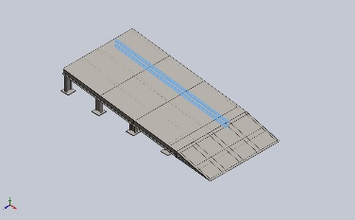 | Beam – Uniform C/S | Section Standard-weldment profiles/iso/sb beam  Section Area: 0.00109003m^2  Length:2,265.04mm  Volume:0.0024703m^3  Mass Density:7,850kg/m^3  Mass:19.3919kg  Weight:190.04N | E:\NIHVA AUTOMATION 2026\AUTOMATION\DOCK RAMP\DOCK RAMP- ASSA ABLOY 04\0403sissior lift ramp.SLDPRT  Oct 21 14:04:33 2025
SolidBody 7(C channel 100 X 10(1)[1])  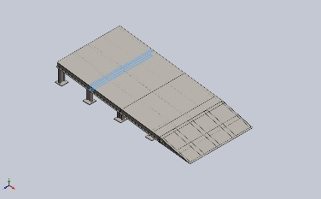 | Beam – Uniform C/S | Section Standard-weldment profiles/iso/c channel  Section Area: 0.00131018m^2  Length:1,350mm  Volume:0.00176874m^3  Mass Density:7,850kg/m^3  Mass:13.8846kg  Weight:136.069N | E:\NIHVA AUTOMATION 2026\AUTOMATION\DOCK RAMP\DOCK RAMP- ASSA ABLOY 04\0403sissior lift ramp.SLDPRT  Oct 21 14:04:33 2025
SolidBody 8(Cut-Extrude5[1])  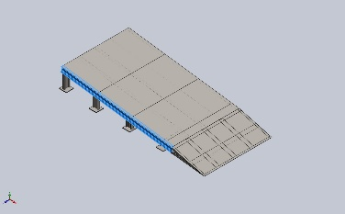 | Beam – Uniform C/S | Section Standard-weldment profiles/iso/sb beam  Section Area: 0.00109003m^2  Length:2,307.92mm  Volume:0.00251577m^3  Mass Density:7,850kg/m^3  Mass:19.7488kg  Weight:193.539N | E:\NIHVA AUTOMATION 2026\AUTOMATION\DOCK RAMP\DOCK RAMP- ASSA ABLOY 04\0403sissior lift ramp.SLDPRT  Oct 21 14:04:33 2025
SolidBody 9(Sb beam 100 X 8(1)[4])  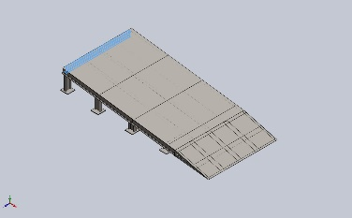 | Beam – Uniform C/S | Section Standard-weldment profiles/iso/sb beam  Section Area: 0.00109003m^2  Length:1,300mm  Volume:0.00141704m^3  Mass Density:7,850kg/m^3  Mass:11.1238kg  Weight:109.013N | E:\NIHVA AUTOMATION 2026\AUTOMATION\DOCK RAMP\DOCK RAMP- ASSA ABLOY 04\0403sissior lift ramp.SLDPRT  Oct 21 14:04:33 2025
SolidBody 10(Cut-Extrude2[7])  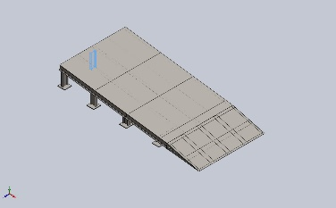 | Beam – Uniform C/S | Section Standard-weldment profiles/iso/sb beam  Section Area: 0.00109003m^2  Length:300mm  Volume:0.000327009m^3  Mass Density:7,850kg/m^3  Mass:2.56702kg  Weight:25.1568N | E:\NIHVA AUTOMATION 2026\AUTOMATION\DOCK RAMP\DOCK RAMP- ASSA ABLOY 04\0403sissior lift ramp.SLDPRT  Oct 21 14:04:33 2025
SolidBody 11(Cut-Extrude5[3])  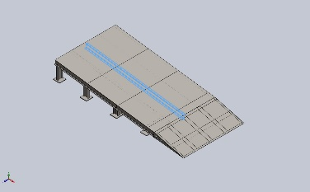 | Beam – Uniform C/S | Section Standard-weldment profiles/iso/sb beam  Section Area: 0.00109003m^2  Length:2,282.6mm  Volume:0.00248845m^3  Mass Density:7,850kg/m^3  Mass:19.5343kg  Weight:191.436N | E:\NIHVA AUTOMATION 2026\AUTOMATION\DOCK RAMP\DOCK RAMP- ASSA ABLOY 04\0403sissior lift ramp.SLDPRT  Oct 21 14:04:33 2025
SolidBody 12(Cut-Extrude2[11])  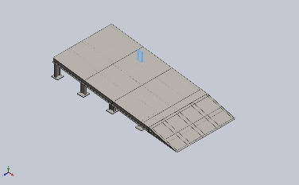 | Beam – Uniform C/S | Section Standard-weldment profiles/iso/sb beam  Section Area: 0.00109003m^2  Length:207.94mm  Volume:0.000226661m^3  Mass Density:7,850kg/m^3  Mass:1.77929kg  Weight:17.437N | E:\NIHVA AUTOMATION 2026\AUTOMATION\DOCK RAMP\DOCK RAMP- ASSA ABLOY 04\0403sissior lift ramp.SLDPRT  Oct 21 14:04:33 2025
SolidBody 13(C channel 100 X 10(1)[2])  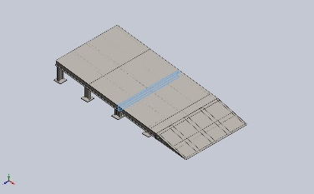 | Beam – Uniform C/S | Section Standard-weldment profiles/iso/c channel  Section Area: 0.00131018m^2  Length:1,350mm  Volume:0.00176874m^3  Mass Density:7,850kg/m^3  Mass:13.8846kg  Weight:136.069N | E:\NIHVA AUTOMATION 2026\AUTOMATION\DOCK RAMP\DOCK RAMP- ASSA ABLOY 04\0403sissior lift ramp.SLDPRT  Oct 21 14:04:33 2025
SolidBody 14(Cut-Extrude2[6])  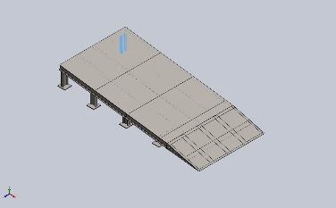 | Beam – Uniform C/S | Section Standard-weldment profiles/iso/sb beam  Section Area: 0.00109003m^2  Length:300mm  Volume:0.000327009m^3  Mass Density:7,850kg/m^3  Mass:2.56702kg  Weight:25.1568N | E:\NIHVA AUTOMATION 2026\AUTOMATION\DOCK RAMP\DOCK RAMP- ASSA ABLOY 04\0403sissior lift ramp.SLDPRT  Oct 21 14:04:33 2025
SolidBody 15(Cut-Extrude2[8])  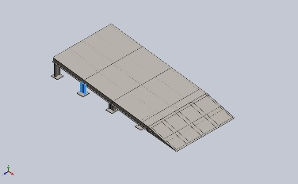 | Beam – Uniform C/S | Section Standard-weldment profiles/iso/sb beam  Section Area: 0.00109003m^2  Length:207.94mm  Volume:0.000226661m^3  Mass Density:7,850kg/m^3  Mass:1.77929kg  Weight:17.437N | E:\NIHVA AUTOMATION 2026\AUTOMATION\DOCK RAMP\DOCK RAMP- ASSA ABLOY 04\0403sissior lift ramp.SLDPRT  Oct 21 14:04:33 2025
SolidBody 16(Cut-Extrude2[12])  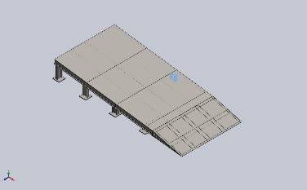 | Beam – Uniform C/S | Section Standard-weldment profiles/iso/sb beam  Section Area: 0.00109003m^2  Length:115.88mm  Volume:0.000126313m^3  Mass Density:7,850kg/m^3  Mass:0.991555kg  Weight:9.71723N | E:\NIHVA AUTOMATION 2026\AUTOMATION\DOCK RAMP\DOCK RAMP- ASSA ABLOY 04\0403sissior lift ramp.SLDPRT  Oct 21 14:04:33 2025
SolidBody 17(Cut-Extrude5[2])  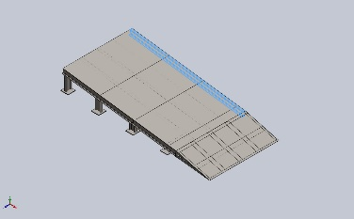 | Beam – Uniform C/S | Section Standard-weldment profiles/iso/sb beam  Section Area: 0.00109003m^2  Length:2,307.92mm  Volume:0.00251577m^3  Mass Density:7,850kg/m^3  Mass:19.7488kg  Weight:193.539N | E:\NIHVA AUTOMATION 2026\AUTOMATION\DOCK RAMP\DOCK RAMP- ASSA ABLOY 04\0403sissior lift ramp.SLDPRT  Oct 21 14:04:33 2025
SolidBody 18(Cut-Extrude5[4])  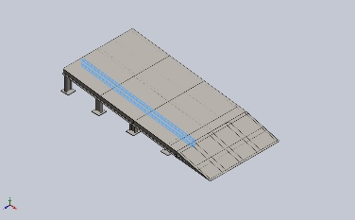 | Beam – Uniform C/S | Section Standard-weldment profiles/iso/sb beam  Section Area: 0.00109003m^2  Length:2,265.04mm  Volume:0.0024703m^3  Mass Density:7,850kg/m^3  Mass:19.3919kg  Weight:190.04N | E:\NIHVA AUTOMATION 2026\AUTOMATION\DOCK RAMP\DOCK RAMP- ASSA ABLOY 04\0403sissior lift ramp.SLDPRT  Oct 21 14:04:33 2025
SolidBody 19(Cut-Extrude2[9])  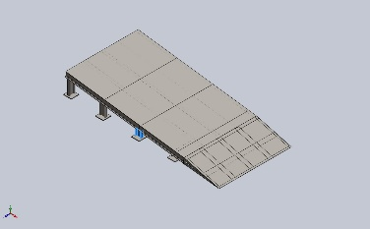 | Beam – Uniform C/S | Section Standard-weldment profiles/iso/sb beam  Section Area: 0.00109003m^2  Length:115.88mm  Volume:0.000126313m^3  Mass Density:7,850kg/m^3  Mass:0.991555kg  Weight:9.71723N | E:\NIHVA AUTOMATION 2026\AUTOMATION\DOCK RAMP\DOCK RAMP- ASSA ABLOY 04\0403sissior lift ramp.SLDPRT  Oct 21 14:04:33 2025

Study Properties
Study name | Static 2
Analysis type | Static
Mesh type | Mixed Mesh
Thermal Effect: | On
Thermal option | Include temperature loads
Zero strain temperature | 298 Kelvin
Include fluid pressure effects from SOLIDWORKS Flow Simulation | Off
Solver type | Automatic
Inplane Effect: | Off
Soft Spring: | Off
Inertial Relief: | Off
Incompatible bonding options | Automatic
Large displacement | Off
Compute free body forces | On
Friction | Off
Use Adaptive Method: | Off
Result folder | SOLIDWORKS document (E:\NIHVA AUTOMATION 2026\AUTOMATION\DOCK RAMP\DOCK RAMP- ASSA ABLOY 04)

Units
Unit system: | SI (MKS)
Length/Displacement | mm
Temperature | Kelvin
Angular velocity | Rad/sec
Pressure/Stress | N/m^2

Material Properties
Model Reference | Properties | Components
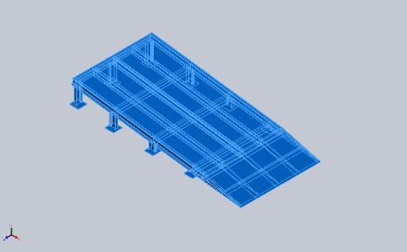 |  | SolidBody 1(Boss-Extrude1)(0403CHEQURED PLATE-1),  SolidBody 1(Trim/Extend1[3])(0403DOCK RAMP2-1),  SolidBody 2(C channel 100 X 10(1))(0403DOCK RAMP2-1),  SolidBody 3(Angle iron 35 X 35 X 5(1)[1])(0403DOCK RAMP2-1),  SolidBody 4(Angle iron 35 X 35 X 5(1)[2])(0403DOCK RAMP2-1),  SolidBody 5(Trim/Extend1[5])(0403DOCK RAMP2-1),  SolidBody 6(Cut-Extrude2)(0403DOCK RAMP2-1),  SolidBody 7(Cut-Extrude4)(0403DOCK RAMP2-1),  SolidBody 8(Trim/Extend1[1])(0403DOCK RAMP2-1),  SolidBody 9(Trim/Extend1[2])(0403DOCK RAMP2-1),  SolidBody 10(Trim/Extend1[4])(0403DOCK RAMP2-1),  SolidBody 1(Boss-Extrude1)(0403SS PLATE-1),  SolidBody 1(Boss-Extrude1)(0403bottom plate-1),  SolidBody 1(Boss-Extrude1)(0403bottom plate-13),  SolidBody 1(Boss-Extrude1)(0403bottom plate-15),  SolidBody 1(Boss-Extrude1)(0403bottom plate-17),  SolidBody 1(Boss-Extrude1)(0403bottom plate-19),  SolidBody 1(Boss-Extrude1)(0403bottom plate-21),  SolidBody 1(Boss-Extrude1)(0403bottom plate-3),  SolidBody 1(Boss-Extrude1)(0403bottom plate-5),  SolidBody 1(Boss-Extrude1)(0403bottom plate-7),  SolidBody 1(Cut-Extrude2[5])(0403sissior lift ramp-1),  SolidBody 2(Cut-Extrude2[13])(0403sissior lift ramp-1),  SolidBody 3(C channel 100 X 10(1)[3])(0403sissior lift ramp-1),  SolidBody 4(Cut-Extrude2[10])(0403sissior lift ramp-1),  SolidBody 5(Cut-Extrude5[6])(0403sissior lift ramp-1),  SolidBody 6(Cut-Extrude5[5])(0403sissior lift ramp-1),  SolidBody 7(C channel 100 X 10(1)[1])(0403sissior lift ramp-1),  SolidBody 8(Cut-Extrude5[1])(0403sissior lift ramp-1),  SolidBody 9(Sb beam 100 X 8(1)[4])(0403sissior lift ramp-1),  SolidBody 10(Cut-Extrude2[7])(0403sissior lift ramp-1),  SolidBody 11(Cut-Extrude5[3])(0403sissior lift ramp-1),  SolidBody 12(Cut-Extrude2[11])(0403sissior lift ramp-1),  SolidBody 13(C channel 100 X 10(1)[2])(0403sissior lift ramp-1),  SolidBody 14(Cut-Extrude2[6])(0403sissior lift ramp-1),  SolidBody 15(Cut-Extrude2[8])(0403sissior lift ramp-1),  SolidBody 16(Cut-Extrude2[12])(0403sissior lift ramp-1),  SolidBody 17(Cut-Extrude5[2])(0403sissior lift ramp-1),  SolidBody 18(Cut-Extrude5[4])(0403sissior lift ramp-1),  SolidBody 19(Cut-Extrude2[9])(0403sissior lift ramp-1)
  Name: | AISI 1045 Steel, cold drawn
  Model type: | Linear Elastic Isotropic
  Default failure criterion: | Max von Mises Stress
  Yield strength: | 5.3e+08 N/m^2
  Tensile strength: | 6.25e+08 N/m^2
  Elastic modulus: | 2.05e+11 N/m^2
  Poisson's ratio: | 0.29
  Mass density: | 7,850 kg/m^3
  Shear modulus: | 8e+10 N/m^2
  Thermal expansion coefficient: | 1.15e-05 /Kelvin
Curve Data:N/A

Loads and Fixtures
Fixture name | Fixture Image | Fixture Details
Fixed-1 | 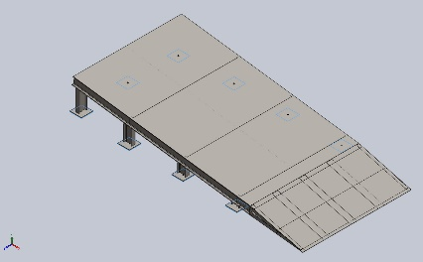
  Entities: | 9 face(s)
  Type: | Fixed Geometry
Resultant Forces
Components | X | Y | Z | Resultant
Reaction force(N) | 975.833 | 4,893.1 | 0.000304222 | 4,989.46
Reaction Moment(N.m) | 0 | 0 | 0 | 1e-33

Load name | Load Image | Load Details
Force-1 | 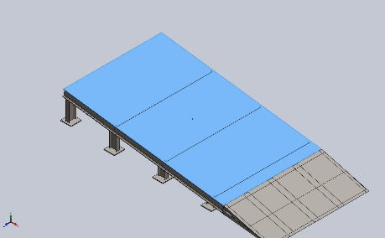
  Entities: | 1 face(s)
  Type: | Apply normal force
  Value: | 2,500 N
Force-2 | 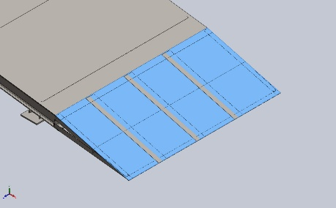
  Entities: | 1 face(s)
  Type: | Apply normal force
  Value: | 2,500 N

Connector Definitions
No Data

Interaction Information

Interaction | Interaction Image | Interaction Properties
Global Interaction | 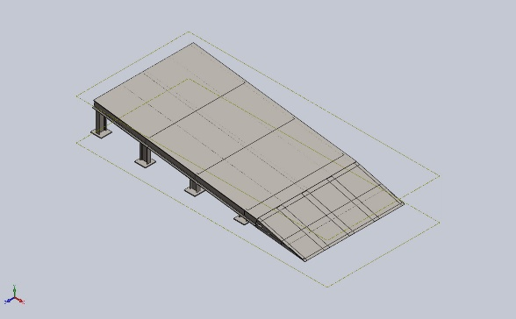
  Type: | Bonded
  Components: | 1 component(s)
  Options: | Independent mesh

Mesh information
Mesh type | Mixed Mesh
Mesher Used: | Blended curvature-based mesh
Jacobian points for High quality mesh | 16 Points
Jacobian check for shell | Off
Maximum element size | 59.7697 mm
Minimum element size | 59.7697 mm
Mesh Quality | High
Remesh failed parts independently | Off

Mesh information - Details
Total Nodes | 19451
Total Elements | 9542
Time to complete mesh(hh;mm;ss): | 00:00:09
Computer name:

Sensor Details
No Data

Resultant Forces

Reaction forces
Selection set | Units | Sum X | Sum Y | Sum Z | Resultant
Entire Model | N | 975.833 | 4,893.1 | 0.000304222 | 4,989.46

Reaction Moments
Selection set | Units | Sum X | Sum Y | Sum Z | Resultant
Entire Model | N.m | 0 | 0 | 0 | 1e-33

Free body forces
Selection set | Units | Sum X | Sum Y | Sum Z | Resultant
Entire Model | N | -0.671347 | 1.1651 | 0.00165558 | 1.34468

Free body moments
Selection set | Units | Sum X | Sum Y | Sum Z | Resultant
Entire Model | N.m | 0 | 0 | 0 | 1e-33

Beams

Beam Forces
Beam Name | Joints | Axial(N) | Shear1(N) | Shear2(N) | Moment1(N.m) | Moment2(N.m) | Torque(N.m)
Beam-1(Trim/Extend1[3]) | 1 | -52.2036 | -22.677 | -37.9599 | -13.0097 | 8.2271 | -0.0437733
Beam-1(Trim/Extend1[3]) | 2 | 1.33141 | 1.56239 | 0.183235 | -0.0236465 | 0.0517413 | 0.00830904
Beam-1(Trim/Extend1[3]) | 3 | -1.33141 | -1.56239 | -0.183226 | -0.0338971 | 0.438939 | -0.00830934
Beam-2(C channel 100 X 10(1)) | 1 | 610.289 | 10.4593 | 1,817.59 | 111.939 | 98.2821 | -3.65945
Beam-2(C channel 100 X 10(1)) | 2 | 43.468 | 129.298 | 1,646.49 | 92.8551 | 12.7634 | -3.61881
Beam-2(C channel 100 X 10(1)) | 3 | -67.1109 | -275.919 | 915.263 | -65.1978 | -46.1411 | -4.08685
Beam-2(C channel 100 X 10(1)) | 4 | 430.742 | 172.703 | 1,697.98 | 109.812 | 78.1145 | -5.49818
Beam-2(C channel 100 X 10(1)) | 5 | 529.451 | 504.207 | 1,635.37 | 90.2951 | 69.1612 | -3.91576
Beam-3(Angle iron 35 X 35 X 5(1)[1]) | 1 | -15.4951 | -0.947215 | -0.155968 | -0.357514 | -0.512293 | -0.0743896
Beam-3(Angle iron 35 X 35 X 5(1)[1]) | 2 | 1.92144 | -1.21578 | 0.440404 | -0.000989849 | 0.0281502 | -0.0094009
Beam-3(Angle iron 35 X 35 X 5(1)[1]) | 3 | -1.92144 | 1.21578 | -0.440404 | 0.0513292 | 0.110817 | 0.0094009
Beam-3(Angle iron 35 X 35 X 5(1)[1]) | 4 | 1.90646 | -1.42381 | 0.524482 | 0.10369 | 0.224866 | -0.00541984
Beam-4(Angle iron 35 X 35 X 5(1)[2]) | 1 | -18.4284 | -5.62489 | -3.24603 | -1.06317 | 1.89758 | 0.0568809
Beam-4(Angle iron 35 X 35 X 5(1)[2]) | 2 | -1.71954 | -0.755441 | -0.174202 | 0.0332027 | -0.0782829 | -0.0087817
Beam-4(Angle iron 35 X 35 X 5(1)[2]) | 3 | 1.76437 | 0.774414 | 0.189333 | 0.0224455 | -0.0803688 | 0.00509261
Beam-4(Angle iron 35 X 35 X 5(1)[2]) | 4 | 1.71954 | 0.755441 | 0.174202 | -0.0147894 | -0.00156787 | 0.0087817
Beam-5(Trim/Extend1[5]) | 1 | 0 | 0 | 0 | 0 | 0 | 0
Beam-5(Trim/Extend1[5]) | 2 | -1.17485 | 0.622562 | 0.349395 | 0.0219093 | -0.034512 | -0.0115867
Beam-5(Trim/Extend1[5]) | 3 | 1.17485 | -0.622562 | -0.349395 | 0.0108067 | -0.0237821 | 0.0115867
Beam-5(Trim/Extend1[5]) | 4 | -1.17249 | 0.41453 | 0.434759 | 0.111542 | -0.160177 | -0.00481952
Beam-6(Cut-Extrude2) | 1 | 5.27435 | -0.712577 | -0.0209532 | -0.00332641 | 0.130175 | -0.00101898
Beam-6(Cut-Extrude2) | 2 | 1.83834 | 0.811257 | -0.0790788 | -0.0158629 | -0.157471 | 0.00768663
Beam-6(Cut-Extrude2) | 3 | -0.592023 | 0.437629 | -0.123897 | 0.021319 | 0.075602 | 0.00691245
Beam-6(Cut-Extrude2) | 4 | 0.592019 | -0.437634 | 0.123902 | 0.0194388 | 0.0683607 | -0.00691256
Beam-6(Cut-Extrude2) | 5 | 6.83147 | 0.637271 | -0.0450416 | -0.00716568 | -0.107063 | 0.00414289
Beam-7(Cut-Extrude4) | 1 | -8.44054 | -20.0835 | -20.0835 | -4.14063 | 4.55625 | 0.118327
Beam-7(Cut-Extrude4) | 2 | 11.2517 | -9.18737 | -7.77465 | -0.346451 | -0.323228 | -0.229709
Beam-7(Cut-Extrude4) | 3 | -21.8344 | -25.1784 | -9.22258 | -0.0836989 | 2.7576 | -0.20147
Beam-7(Cut-Extrude4) | 4 | -28.5685 | 29.7783 | 19.534 | 3.57401 | -5.06004 | -0.0315456
Beam-7(Cut-Extrude4) | 5 | -11.2517 | 9.18738 | 7.77464 | 3.23117 | -3.08568 | 0.22971
Beam-8(Trim/Extend1[1]) | 1 | 0 | 0 | 0 | 0 | 0 | 0
Beam-8(Trim/Extend1[1]) | 2 | 0 | 0 | 0 | 0 | 0 | 0
Beam-8(Trim/Extend1[1]) | 3 | -1.35849 | 0.182395 | 0.113356 | 0.0333069 | 0.0211939 | 0.00492276
Beam-8(Trim/Extend1[1]) | 4 | -1.31192 | 0.163422 | 0.105028 | 0.0092068 | -0.00331738 | 0.0100057
Beam-9(Trim/Extend1[2]) | 1 | 55.9771 | 2.7569 | 27.1571 | 8.67484 | 0.626089 | 0.130641
Beam-9(Trim/Extend1[2]) | 2 | -0.293339 | 4.68342 | -0.0188938 | 0.0157737 | 0.289119 | -0.0372329
Beam-9(Trim/Extend1[2]) | 3 | 0.293339 | -4.68342 | 0.0188617 | -0.00984805 | 1.18175 | 0.0372338
Beam-10(Trim/Extend1[4]) | 1 | 29.8163 | 8.50248 | 26.819 | 8.96941 | -5.02841 | -0.22245
Beam-10(Trim/Extend1[4]) | 2 | 0.167006 | -4.98991 | 0.188875 | -0.0104017 | -0.357889 | 0.0483838
Beam-10(Trim/Extend1[4]) | 3 | -0.167006 | 4.98991 | -0.188842 | -0.0489081 | -1.20923 | -0.0483847
Beam-11(Cut-Extrude2[5]) | 1 | -78.0242 | -49.335 | 107.519 | -16.8984 | -10.8345 | -0.0343383
Beam-11(Cut-Extrude2[5]) | 2 | 78.0242 | 49.335 | -107.519 | -15.3572 | -3.96604 | 0.0343383
Beam-12(Cut-Extrude2[13]) | 1 | 0 | 0 | 0 | 0 | 0 | 0
Beam-12(Cut-Extrude2[13]) | 2 | 0 | 0 | 0 | 0 | 0 | 0
Beam-13(C channel 100 X 10(1)[3]) | 1 | -814.639 | 419.941 | -11.7915 | 4.02815 | 19.707 | 0.544297
Beam-13(C channel 100 X 10(1)[3]) | 2 | 1,379.29 | -329.542 | 12.618 | -0.680562 | 203.648 | -0.23912
Beam-13(C channel 100 X 10(1)[3]) | 3 | 1,315.96 | 343.384 | -28.7371 | -7.49306 | 93.5309 | 0.379008
Beam-13(C channel 100 X 10(1)[3]) | 4 | 745.131 | 434.069 | -40.8219 | -9.66359 | -20.0302 | 0.788177
Beam-13(C channel 100 X 10(1)[3]) | 5 | 814.639 | -419.941 | 11.7915 | -0.0485074 | 122.023 | -0.544297
Beam-15(Cut-Extrude5[6]) | 1 | -1,585.21 | 142.72 | -72.6915 | -3.68448 | 29.1978 | -0.0937033
Beam-15(Cut-Extrude5[6]) | 2 | -1,542.45 | 142.046 | 15.3985 | 0.920542 | 113.401 | 0.0234903
Beam-15(Cut-Extrude5[6]) | 3 | -1,899.23 | -329.694 | 13.2622 | 0.274533 | 101.066 | 0.0666673
Beam-15(Cut-Extrude5[6]) | 4 | -422.951 | 204.208 | -4.80278 | 0.43166 | 6.10362 | -0.0604663
Beam-15(Cut-Extrude5[6]) | 5 | -2,724.19 | -313.639 | 13.0265 | 0.6863 | 206.441 | -0.145682
Beam-16(Cut-Extrude5[5]) | 1 | -2,730.43 | 593.018 | -80.3515 | -7.20238 | 81.3294 | -0.0511554
Beam-16(Cut-Extrude5[5]) | 2 | -2,471.55 | 157.068 | -70.2446 | -7.80184 | 141.185 | 0.585912
Beam-16(Cut-Extrude5[5]) | 3 | -985.347 | -122.38 | 16.5412 | 2.54764 | 50.9443 | -0.116449
Beam-16(Cut-Extrude5[5]) | 4 | 30.9277 | 84.6884 | 15.6313 | -0.453459 | 3.39982 | 0.163705
Beam-16(Cut-Extrude5[5]) | 5 | -3,579.15 | -212.008 | -61.7956 | -2.95516 | 207.636 | 1.05569
Beam-17(C channel 100 X 10(1)[1]) | 1 | -205.691 | -94.2802 | -29.9984 | -5.58182 | 28.3638 | 0.245198
Beam-17(C channel 100 X 10(1)[1]) | 2 | -195.179 | 125.974 | 36.5757 | 4.72347 | -14.0824 | -0.227964
Beam-17(C channel 100 X 10(1)[1]) | 3 | 86.7523 | -83.6986 | 7.76718 | -1.48916 | -16.8331 | -0.145503
Beam-17(C channel 100 X 10(1)[1]) | 4 | -193.342 | -62.3136 | 18.4044 | 4.0169 | 3.96943 | -0.23198
Beam-17(C channel 100 X 10(1)[1]) | 5 | -86.7523 | 83.6986 | -7.76718 | -1.13226 | -11.4152 | 0.145503
Beam-18(Cut-Extrude5[1]) | 1 | -1,724.47 | 643.811 | -300.697 | -27 | 13.4629 | 0.105358
Beam-18(Cut-Extrude5[1]) | 2 | -131.532 | 42.3135 | 23.1317 | -3.00602 | 20.1214 | 0.111198
Beam-18(Cut-Extrude5[1]) | 3 | -2,410.94 | 897.582 | 101.676 | 9.12735 | 67.5677 | 0.0822392
Beam-18(Cut-Extrude5[1]) | 4 | -306.547 | -129.653 | 17.0629 | 2.12507 | 26.814 | 0.200513
Beam-18(Cut-Extrude5[1]) | 5 | -3,825.33 | -674.617 | 112.339 | 11.4285 | 182.28 | -0.943816
Beam-19(Sb beam 100 X 8(1)[4]) | 1 | -91.732 | 41.1581 | 5.4967 | -0.798902 | 10.9256 | 0.0572294
Beam-19(Sb beam 100 X 8(1)[4]) | 2 | 81.7748 | 0.835829 | 3.60738 | 0.835089 | 2.36867 | -0.00770792
Beam-19(Sb beam 100 X 8(1)[4]) | 3 | 11.5453 | 2.97026 | 10.9704 | -0.72064 | 3.38599 | 0.0567217
Beam-19(Sb beam 100 X 8(1)[4]) | 4 | 11.5453 | 2.97026 | 10.9704 | 1.85054 | 2.68984 | 0.0567217
Beam-19(Sb beam 100 X 8(1)[4]) | 5 | 91.732 | -41.1581 | -5.49683 | -1.05624 | 2.96523 | -0.0572295
Beam-20(Cut-Extrude2[7]) | 1 | 457.102 | 71.2434 | -95.791 | -14.8268 | -8.59889 | 0.0269527
Beam-20(Cut-Extrude2[7]) | 2 | -457.102 | -71.2434 | 95.791 | -13.9105 | -12.7741 | -0.0269527
Beam-21(Cut-Extrude5[3]) | 1 | -1,643.73 | 483.865 | -19.4719 | -1.30296 | 17.0568 | -0.04151
Beam-21(Cut-Extrude5[3]) | 2 | -2,107.24 | 113.092 | -0.922514 | -0.734555 | 100.433 | -0.0414039
Beam-21(Cut-Extrude5[3]) | 3 | -690.344 | -165.349 | -1.52512 | -0.661604 | 97.425 | 0.00809732
Beam-21(Cut-Extrude5[3]) | 4 | 690.344 | 165.35 | 1.5251 | -0.418784 | 19.7076 | -0.00809698
Beam-21(Cut-Extrude5[3]) | 5 | -1,966.59 | -164.409 | -0.702326 | -0.547462 | 195.831 | -0.0186602
Beam-22(Cut-Extrude2[11]) | 1 | -636.178 | -765.624 | -61.4837 | 7.67462 | -98.1648 | -0.0129107
Beam-22(Cut-Extrude2[11]) | 2 | 636.178 | 765.624 | 61.4837 | 8.21142 | -99.6556 | 0.0129107
Beam-23(C channel 100 X 10(1)[2]) | 1 | 1,793.9 | -526.398 | -23.7206 | -9.15946 | 304.437 | 0.162825
Beam-23(C channel 100 X 10(1)[2]) | 2 | 1,965.8 | 376.927 | 16.7528 | -1.70431 | 168.057 | -0.132411
Beam-23(C channel 100 X 10(1)[2]) | 3 | 207.587 | 1,469.02 | 165.262 | -32.8551 | 277.631 | -1.24085
Beam-23(C channel 100 X 10(1)[2]) | 4 | -18.6824 | 1,388.26 | 114.559 | 18.6749 | -207.169 | -1.09792
Beam-23(C channel 100 X 10(1)[2]) | 5 | -207.587 | -1,469.02 | -165.262 | -22.9209 | 218.163 | 1.24085
Beam-24(Cut-Extrude2[6]) | 1 | 10.9611 | -41.3493 | 71.5166 | -11.2418 | -12.0358 | 0.0122016
Beam-24(Cut-Extrude2[6]) | 2 | -10.9611 | 41.3493 | -71.5166 | -10.2132 | -0.369031 | -0.0122016
Beam-25(Cut-Extrude2[8]) | 1 | 465.321 | 998.041 | 47.8621 | 5.21483 | -115.613 | 0.0400934
Beam-25(Cut-Extrude2[8]) | 2 | -465.321 | -998.041 | -47.8621 | 7.1517 | -142.259 | -0.0400934
Beam-26(Cut-Extrude2[12]) | 1 | 3,248.82 | 1,595.34 | -1,403.49 | 85.888 | -187.375 | 0.240661
Beam-26(Cut-Extrude2[12]) | 2 | -3,248.82 | -1,595.34 | 1,403.49 | 147.538 | 452.709 | -0.240661
Beam-27(Cut-Extrude5[2]) | 1 | -2,214.33 | 482.338 | 147.214 | 13.4478 | 35.0668 | -0.118986
Beam-27(Cut-Extrude5[2]) | 2 | -2,598.88 | 868.421 | -108.7 | -9.69115 | 82.0635 | 0.0157373
Beam-27(Cut-Extrude5[2]) | 3 | 497.452 | -732.219 | 34.1072 | -1.99894 | -29.3981 | 0.526476
Beam-27(Cut-Extrude5[2]) | 4 | -112.177 | -14.7163 | -27.977 | 3.90514 | 9.6345 | -0.0674716
Beam-27(Cut-Extrude5[2]) | 5 | -3,297.44 | -783.088 | -6.40606 | 1.49994 | 200.648 | -0.00121818
Beam-28(Cut-Extrude5[4]) | 1 | -2,879.69 | 548.123 | 64.4018 | 7.85761 | 66.2896 | 0.272837
Beam-28(Cut-Extrude5[4]) | 2 | -2,362.03 | 85.9303 | 46.923 | 4.96077 | 139.908 | -0.352998
Beam-28(Cut-Extrude5[4]) | 3 | -884.254 | -97.0739 | -25.093 | -2.93212 | 44.5355 | -0.0267802
Beam-28(Cut-Extrude5[4]) | 4 | 21.2837 | 71.9199 | -3.65926 | 0.738673 | 2.58463 | -0.0846383
Beam-28(Cut-Extrude5[4]) | 5 | -3,532.16 | -579.482 | 54.8345 | 3.21474 | 273.65 | -1.43613
Beam-29(Cut-Extrude2[9]) | 1 | -3,269.94 | -1,418.99 | -1,674.77 | -131.686 | 455.534 | 0.0578428
Beam-29(Cut-Extrude2[9]) | 2 | 3,269.94 | 1,418.99 | 1,674.77 | -62.3862 | -291.102 | -0.0578428

Beam Stresses
Beam Name | Joints | Axial(N/m^2) | Bending Dir1(N/m^2) | Bending Dir2(N/m^2) | Torsional (N/m^2) | Upper bound axial and bending(N/m^2)
Beam-1(Trim/Extend1[3]) | 1 | -60,965.9 | -1.52892e+06 | -98,429.3 | -294,170 | 1.68831e+06
Beam-1(Trim/Extend1[3]) | 2 | -1,554.89 | -1,313.17 | 7,090.03 | -55,839.3 | 9,958.09
Beam-1(Trim/Extend1[3]) | 3 | -1,554.89 | 42,458.1 | -78,690.9 | -55,841.3 | 122,704
Beam-2(C channel 100 X 10(1)) | 1 | 465,807 | 1.42328e+07 | -2.45787e+06 | -1.08921e+07 | 1.71565e+07
Beam-2(C channel 100 X 10(1)) | 2 | 33,177.2 | 1.18062e+07 | -319,191 | -1.07711e+07 | 1.21586e+07
Beam-2(C channel 100 X 10(1)) | 3 | 51,222.8 | 8.28971e+06 | -1.15391e+06 | 1.21642e+07 | 9.49485e+06
Beam-2(C channel 100 X 10(1)) | 4 | 328,767 | 1.39622e+07 | -1.95352e+06 | -1.6365e+07 | 1.62445e+07
Beam-2(C channel 100 X 10(1)) | 5 | 404,107 | 1.14808e+07 | -1.72961e+06 | -1.1655e+07 | 1.36145e+07
Beam-3(Angle iron 35 X 35 X 5(1)[1]) | 1 | -48,477.4 | -65,452.3 | 343,361 | -837,825 | 457,291
Beam-3(Angle iron 35 X 35 X 5(1)[1]) | 2 | 6,011.35 | -19,778.1 | -32,543.6 | -105,879 | 58,333.1
Beam-3(Angle iron 35 X 35 X 5(1)[1]) | 3 | 6,011.35 | 15,301.1 | 91,510.3 | -105,879 | 112,823
Beam-3(Angle iron 35 X 35 X 5(1)[1]) | 4 | 5,964.5 | -31,575.5 | -185,998 | -61,041.8 | 223,538
Beam-4(Angle iron 35 X 35 X 5(1)[2]) | 1 | -57,654.5 | 53,328.3 | -1.44489e+06 | 640,630 | 1.55588e+06
Beam-4(Angle iron 35 X 35 X 5(1)[2]) | 2 | 5,379.69 | 14,272 | -66,670.8 | 98,905.3 | 86,322.5
Beam-4(Angle iron 35 X 35 X 5(1)[2]) | 3 | 5,519.95 | -27,839.8 | 76,163 | 57,356.3 | 109,523
Beam-4(Angle iron 35 X 35 X 5(1)[2]) | 4 | 5,379.69 | -17,792.1 | 11,577.9 | 98,905.3 | 34,749.7
Beam-5(Trim/Extend1[5]) | 1 | 0 | 0 | 0 | 0 | 0
Beam-5(Trim/Extend1[5]) | 2 | -3,675.61 | 1,944.84 | 24,573.4 | -130,509 | 30,193.8
Beam-5(Trim/Extend1[5]) | 3 | -3,675.61 | 3,520.48 | -19,777.3 | -130,509 | 26,973.4
Beam-5(Trim/Extend1[5]) | 4 | -3,668.22 | 20,192.1 | 107,517 | -54,285.4 | 131,378
Beam-6(Cut-Extrude2) | 1 | 60,961.7 | 162,519 | -599,785 | -89,748.4 | 823,266
Beam-6(Cut-Extrude2) | 2 | 21,247.8 | -886,324 | 1.0351e+06 | 677,011 | 1.94267e+06
Beam-6(Cut-Extrude2) | 3 | 6,842.69 | -900,789 | 710,253 | -608,824 | 1.61789e+06
Beam-6(Cut-Extrude2) | 4 | 6,842.64 | 820,119 | -644,741 | -608,834 | 1.4717e+06
Beam-6(Cut-Extrude2) | 5 | 78,959.1 | -477,073 | 647,416 | 364,891 | 1.20345e+06
Beam-7(Cut-Extrude4) | 1 | -11,797.5 | -971,706 | -127,404 | 936,160 | 1.11091e+06
Beam-7(Cut-Extrude4) | 2 | -15,726.7 | 179,167 | -127,140 | 1.81737e+06 | 322,034
Beam-7(Cut-Extrude4) | 3 | -30,518.2 | 350,652 | -523,981 | -1.59395e+06 | 905,151
Beam-7(Cut-Extrude4) | 4 | -39,930.6 | 682,133 | 330,480 | -249,576 | 1.05254e+06
Beam-7(Cut-Extrude4) | 5 | -15,726.7 | 823,548 | 7,516.22 | 1.81738e+06 | 846,791
Beam-8(Trim/Extend1[1]) | 1 | 0 | 0 | 0 | 0 | 0
Beam-8(Trim/Extend1[1]) | 2 | 0 | 0 | 0 | 0 | 0
Beam-8(Trim/Extend1[1]) | 3 | -4,250.13 | 23,682.4 | -1,933.21 | 55,467.5 | 29,865.8
Beam-8(Trim/Extend1[1]) | 4 | -4,104.42 | 12,627.8 | 9,859.74 | 112,740 | 26,591.9
Beam-9(Trim/Extend1[2]) | 1 | 65,372.9 | 1.69935e+06 | -1.08258e+06 | 877,949 | 2.8473e+06
Beam-9(Trim/Extend1[2]) | 2 | 342.576 | -35,124 | 56,070 | 250,217 | 91,536.6
Beam-9(Trim/Extend1[2]) | 3 | 342.576 | 129,604 | -220,914 | 250,223 | 350,860
Beam-10(Trim/Extend1[4]) | 1 | 34,821 | 1.1257e+06 | -53,064.1 | -1.49493e+06 | 1.21358e+06
Beam-10(Trim/Extend1[4]) | 2 | -195.037 | 41,764.6 | -68,392.1 | -325,154 | 110,352
Beam-10(Trim/Extend1[4]) | 3 | -195.037 | -143,699 | 232,613 | -325,160 | 376,507
Beam-11(Cut-Extrude2[5]) | 1 | 71,579.8 | 3.50045e+06 | -309,992 | 105,203 | 3.88202e+06
Beam-11(Cut-Extrude2[5]) | 2 | 71,579.8 | -3.1812e+06 | 113,475 | 105,203 | 3.36626e+06
Beam-12(Cut-Extrude2[13]) | 1 | 0 | 0 | 0 | 0 | 0
Beam-12(Cut-Extrude2[13]) | 2 | 0 | 0 | 0 | 0 | 0
Beam-13(C channel 100 X 10(1)[3]) | 1 | 621,778 | -512,168 | 492,839 | -1.62006e+06 | 1.62679e+06
Beam-13(C channel 100 X 10(1)[3]) | 2 | 1.05275e+06 | -86,531.5 | -5.09291e+06 | -711,724 | 6.23219e+06
Beam-13(C channel 100 X 10(1)[3]) | 3 | 1.00442e+06 | -952,721 | -2.33905e+06 | 1.12809e+06 | 4.29619e+06
Beam-13(C channel 100 X 10(1)[3]) | 4 | 568,726 | -1.2287e+06 | 500,922 | 2.34595e+06 | 2.29835e+06
Beam-13(C channel 100 X 10(1)[3]) | 5 | 621,778 | -6,167.57 | -3.0516e+06 | -1.62006e+06 | 3.67954e+06
Beam-15(Cut-Extrude5[6]) | 1 | -1.45428e+06 | -763,229 | -835,398 | -286,980 | 3.05291e+06
Beam-15(Cut-Extrude5[6]) | 2 | -1.41505e+06 | 190,688 | -3.24459e+06 | 71,942.4 | 4.85033e+06
Beam-15(Cut-Extrude5[6]) | 3 | -1.74237e+06 | 56,868.7 | -2.89168e+06 | 204,178 | 4.69091e+06
Beam-15(Cut-Extrude5[6]) | 4 | 388,018 | -89,417.2 | 174,635 | 185,187 | 652,070
Beam-15(Cut-Extrude5[6]) | 5 | -2.49918e+06 | 142,165 | -5.90663e+06 | -446,172 | 8.54798e+06
Beam-16(Cut-Extrude5[5]) | 1 | -2.50491e+06 | -1.49195e+06 | -2.32697e+06 | -156,671 | 6.32383e+06
Beam-16(Cut-Extrude5[5]) | 2 | -2.26741e+06 | -1.61613e+06 | -4.03953e+06 | 1.79444e+06 | 7.92307e+06
Beam-16(Cut-Extrude5[5]) | 3 | -903,962 | 527,736 | -1.4576e+06 | -356,642 | 2.8893e+06
Beam-16(Cut-Extrude5[5]) | 4 | -28,373.2 | 93,932.7 | 97,274.5 | -501,370 | 219,580
Beam-16(Cut-Extrude5[5]) | 5 | -3.28353e+06 | -612,154 | -5.9408e+06 | 3.23319e+06 | 9.83649e+06
Beam-17(C channel 100 X 10(1)[1]) | 1 | -156,995 | -709,713 | -709,332 | 729,814 | 1.57604e+06
Beam-17(C channel 100 X 10(1)[1]) | 2 | -148,972 | 600,576 | 352,177 | -678,518 | 1.10173e+06
Beam-17(C channel 100 X 10(1)[1]) | 3 | -66,214.2 | 189,342 | -420,968 | 433,078 | 676,525
Beam-17(C channel 100 X 10(1)[1]) | 4 | -147,569 | 510,737 | -99,268.8 | -690,472 | 757,575
Beam-17(C channel 100 X 10(1)[1]) | 5 | -66,214.2 | -143,964 | 285,475 | 433,078 | 495,653
Beam-18(Cut-Extrude5[1]) | 1 | -1.58204e+06 | -5.59296e+06 | -385,197 | 322,674 | 7.5602e+06
Beam-18(Cut-Extrude5[1]) | 2 | 120,668 | 622,688 | 575,706 | -340,559 | 1.31906e+06
Beam-18(Cut-Extrude5[1]) | 3 | -2.21181e+06 | 1.8907e+06 | -1.93322e+06 | 251,869 | 6.03574e+06
Beam-18(Cut-Extrude5[1]) | 4 | -281,227 | 440,203 | -767,193 | 614,100 | 1.48862e+06
Beam-18(Cut-Extrude5[1]) | 5 | -3.50938e+06 | 2.36738e+06 | -5.21533e+06 | -2.89058e+06 | 1.10921e+07
Beam-19(Sb beam 100 X 8(1)[4]) | 1 | 84,155.4 | 165,490 | 312,601 | -175,295 | 562,246
Beam-19(Sb beam 100 X 8(1)[4]) | 2 | 75,020.7 | 172,986 | -67,771.6 | -23,609.6 | 315,779
Beam-19(Sb beam 100 X 8(1)[4]) | 3 | 10,591.7 | -149,279 | -96,878.8 | 173,740 | 256,749
Beam-19(Sb beam 100 X 8(1)[4]) | 4 | 10,591.7 | 383,334 | -76,960.6 | 173,740 | 470,886
Beam-19(Sb beam 100 X 8(1)[4]) | 5 | 84,155.4 | -218,798 | -84,840.2 | -175,296 | 387,794
Beam-20(Cut-Extrude2[7]) | 1 | 419,347 | -3.07132e+06 | 246,028 | 82,575.7 | 3.7367e+06
Beam-20(Cut-Extrude2[7]) | 2 | 419,347 | 2.88152e+06 | -365,489 | 82,575.7 | 3.66636e+06
Beam-21(Cut-Extrude5[3]) | 1 | -1.50796e+06 | -269,904 | -488,024 | -127,220 | 2.26589e+06
Beam-21(Cut-Extrude5[3]) | 2 | -1.93319e+06 | -152,161 | -2.87355e+06 | -126,895 | 4.9589e+06
Beam-21(Cut-Extrude5[3]) | 3 | -633,326 | -137,049 | -2.78749e+06 | 24,816.7 | 3.55787e+06
Beam-21(Cut-Extrude5[3]) | 4 | -633,326 | 86,749.9 | 563,868 | 24,815.6 | 1.28394e+06
Beam-21(Cut-Extrude5[3]) | 5 | -1.80416e+06 | -113,405 | -5.60305e+06 | -57,189.9 | 7.52061e+06
Beam-22(Cut-Extrude2[11]) | 1 | 583,633 | -1.58978e+06 | -2.80866e+06 | 39,554.8 | 4.98207e+06
Beam-22(Cut-Extrude2[11]) | 2 | 583,633 | 1.70097e+06 | 2.85131e+06 | 39,554.8 | 5.13592e+06
Beam-23(C channel 100 X 10(1)[2]) | 1 | 1.36921e+06 | -1.1646e+06 | -7.61347e+06 | 484,637 | 1.01473e+07
Beam-23(C channel 100 X 10(1)[2]) | 2 | 1.50041e+06 | -216,698 | -4.20283e+06 | -394,113 | 5.91993e+06
Beam-23(C channel 100 X 10(1)[2]) | 3 | -158,442 | 4.17742e+06 | 6.94308e+06 | 3.69332e+06 | 1.1279e+07
Beam-23(C channel 100 X 10(1)[2]) | 4 | -14,259.4 | 2.37446e+06 | 5.18096e+06 | -3.26788e+06 | 7.56968e+06
Beam-23(C channel 100 X 10(1)[2]) | 5 | -158,442 | -2.91432e+06 | -5.45588e+06 | 3.69332e+06 | 8.52865e+06
Beam-24(Cut-Extrude2[6]) | 1 | -10,055.7 | 2.32871e+06 | -344,363 | -37,382.3 | 2.68313e+06
Beam-24(Cut-Extrude2[6]) | 2 | -10,055.7 | -2.11563e+06 | 10,558.6 | -37,382.3 | 2.13624e+06
Beam-25(Cut-Extrude2[8]) | 1 | 426,888 | 1.08024e+06 | 3.30787e+06 | 122,835 | 4.81499e+06
Beam-25(Cut-Extrude2[8]) | 2 | 426,888 | -1.48145e+06 | -4.07027e+06 | 122,835 | 5.97862e+06
Beam-26(Cut-Extrude2[12]) | 1 | -2.98048e+06 | -1.77915e+07 | -5.36112e+06 | -737,318 | 2.61331e+07
Beam-26(Cut-Extrude2[12]) | 2 | -2.98048e+06 | 3.05621e+07 | -1.29527e+07 | -737,318 | 4.64953e+07
Beam-27(Cut-Extrude5[2]) | 1 | -2.03144e+06 | 2.78567e+06 | -1.00332e+06 | -364,411 | 5.82042e+06
Beam-27(Cut-Extrude5[2]) | 2 | -2.38423e+06 | -2.00749e+06 | -2.34797e+06 | 48,197.8 | 6.7397e+06
Beam-27(Cut-Extrude5[2]) | 3 | 456,365 | -414,075 | 841,127 | 1.61241e+06 | 1.71157e+06
Beam-27(Cut-Extrude5[2]) | 4 | 102,912 | -808,938 | 275,659 | 206,642 | 1.18751e+06
Beam-27(Cut-Extrude5[2]) | 5 | -3.02509e+06 | 310,708 | -5.74088e+06 | -3,730.86 | 9.07667e+06
Beam-28(Cut-Extrude5[4]) | 1 | -2.64185e+06 | 1.62768e+06 | -1.89666e+06 | 835,603 | 6.16618e+06
Beam-28(Cut-Extrude5[4]) | 2 | -2.16694e+06 | 1.02761e+06 | -4.003e+06 | -1.08111e+06 | 7.19755e+06
Beam-28(Cut-Extrude5[4]) | 3 | -811,219 | -607,380 | -1.27423e+06 | -82,018.2 | 2.69283e+06
Beam-28(Cut-Extrude5[4]) | 4 | -19,525.7 | -153,014 | 73,950.6 | 259,217 | 246,490
Beam-28(Cut-Extrude5[4]) | 5 | -3.24043e+06 | 665,925 | -7.82959e+06 | -4.39835e+06 | 1.17359e+07
Beam-29(Cut-Extrude2[9]) | 1 | -2.99986e+06 | -2.72783e+07 | -1.30336e+07 | 177,214 | 4.33117e+07
Beam-29(Cut-Extrude2[9]) | 2 | -2.99986e+06 | 1.29231e+07 | -8.32892e+06 | 177,214 | 2.42519e+07

Study Results

Name | Type | Min | Max
Stress1 | VON: von Mises Stress | 0.000e+00N/m^2  Node: 18254 | 1.285e+08N/m^2  Node: 14325
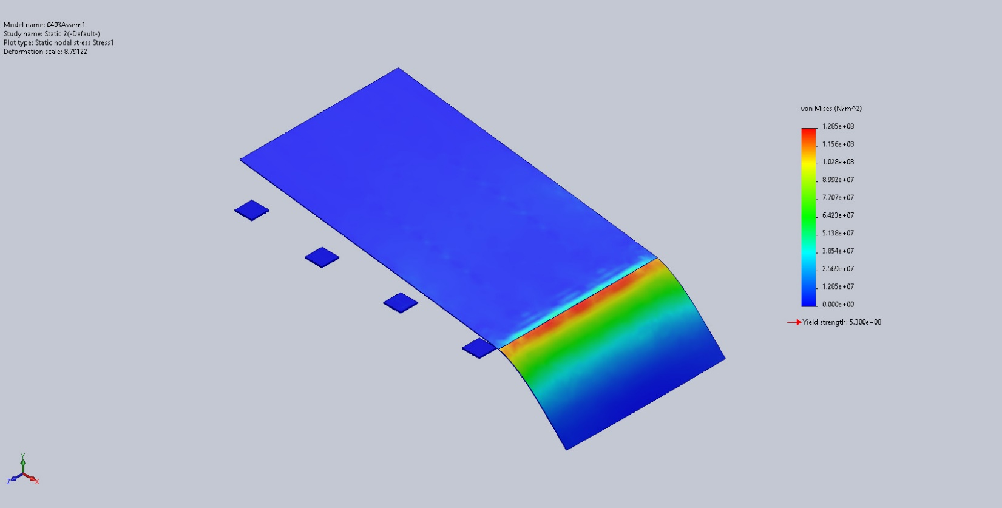
0403Assem1-Static 2-Stress-Stress1

Name | Type | Min | Max
Displacement1 | URES: Resultant Displacement | 0.000e+00mm  Node: 16939 | 3.561e+01mm  Node: 12974
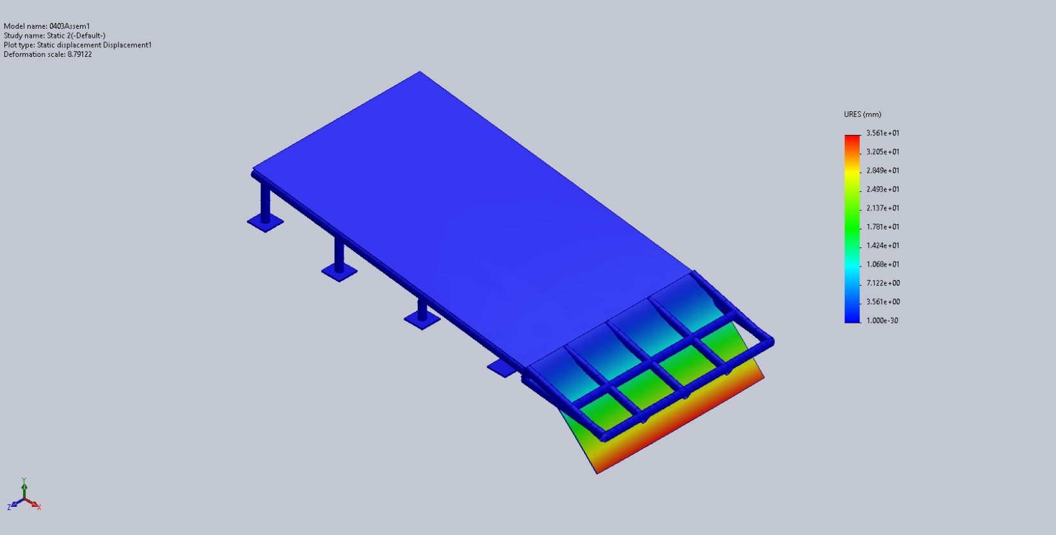
0403Assem1-Static 2-Displacement-Displacement1

Name | Type | Min | Max
Strain1 | ESTRN: Equivalent Strain | 0.000e+00  Element: 8805 | 3.620e-04  Element: 8051
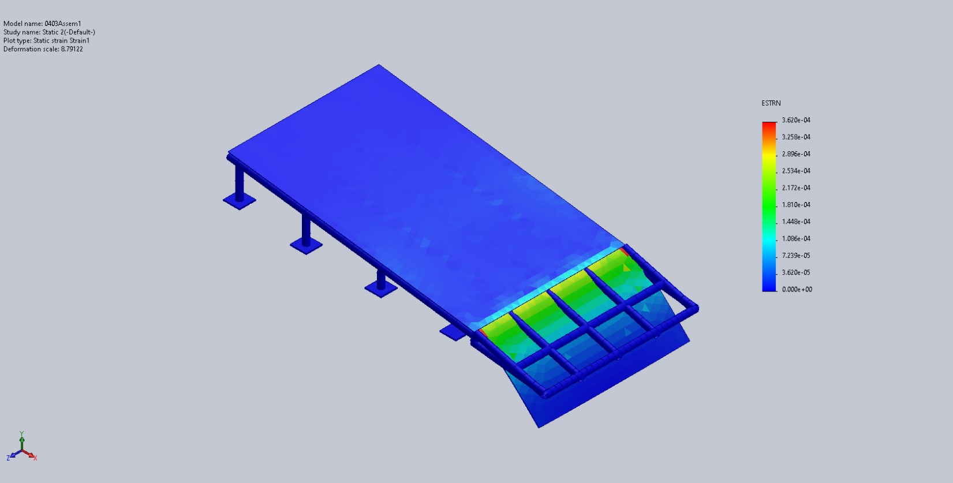
0403Assem1-Static 2-Strain-Strain1

Conclusion

